
Common Security Module
CSM CaGrid User Migration
Design Document

Version No: 1.0
Last Modified: 07/14/2008

Author : Vijay Parmar
Team : Common Security Module
Purchase Order # 34552
Client : National Cancer Institute - Center for Bioinformatics,
National Institutes of Health,
US Department of Health and Human Services

Document History

Document Location
The most current version of this document is located in CVS under security/docs/CSM 4.1/development/design.

Revision History
Version Number | Revision Date | Author | Summary of Changes
0.1 | 07/11/2008 | Vijay Parmar | Initial Draft
1.0 | 07/31/2008 | Vijay Parmar | Provide interaction detail amongst all components of the migration module

Review
Name | Team/Role | Version | Date Reviewed | Reviewer Comments
Charles Griffin | Project Manager | 1.0 | 08/04/2008
Kunal Modi | Security Solution Architect | 1.0 | 08/04/2008

Related Documents
More information can be found in the following related CSM documents:

Document Name
Security Solutions Arch 1 Document

Table of Contents

1. Introduction 4
1.1 Problem Scenario 4
1.2 Scope 4
2. Requirement Analysis 5
2.1 Requirements 5
2.1.1 Business Requirements 5
2.1.2 Technical Requirements 5
2.1.3 Policy Requirements 6
2.2 Assumptions 6
2.3 Dependencies 6
2.4 Known Issues or Future Considerations 6
2.5 Technical Environment 6
3. Detail Design 7
3.1 CSM CaGrid User Migration 7
3.2 Overview 7
3.2.1 Components of CSM Grid User Migration Module 7
3.2.2 CGMM Workflow 8
3.2.3 Deployment Model 10
3.2.4 Database Changes 10
3.3 Integration of Migration Module with Host Application 11
3.3.1 Pass of control from Host Application to CGMM 11
3.3.2 Passing of control from CGMM to Host Application 11
3.4 Interaction of Migration Module with Authentication Service 12
3.5 Integration of Migration Module with Dorian Service 12
4. Unit Testing 14
4.1 JUnit Test Cases 14
4.2 Test Case Scenarios 14
5. Configuration/Deployment Considerations 15
5.1 Property/Configuration Files 15
5.2 Deployment Considerations 15

Introduction
The Common Security Module (CSM) was chartered to provide a comprehensive solution to common security objectives so not all development teams need to create their own security methodology. caGrid is the underlying service oriented infrastructure that supports caBIG. The Grid Authentication and Authorization with Reliably Distributed Services (GAARDS) provides services and tools for the administration and enforcement of security policy in an enterprise Grid. GAARDS was developed on top of the Globus Toolkit and extends the Grid Security Infrastructure (GSI) to provide enterprise services and administrative.

Problem Scenario

The Existing Web Applications use CSM for authentication and authorization. Using CSM, these existing applications have been able to authenticate the application users against local Institution Credential Provider (CP) (also known as Identity Provider - IdP).

The existing web applications are increasingly hosting CaGrid services that require Grid based Authentication. Hence the User base includes Local and Grid Users. With the adoption of caBIG and growing user base the existing web applications are supporting or would like to support additional Credential Providers including Grid supported Identity Providers and their Users. The existing Users of the web applications also have or need to have Grid Credentials. It is difficult to maintain and provision Users with two different authentication methods.

Currently, there are no tools available to assist existing web applications to automatically migrate Users with CSM credentials to Grid credentials. Also currently, to incorporate existing Users with Grid credentials the existing web applications to provision user security as 1) Provision twice for each User; namely the User’s CSM Local Account and Grid Account or 2) Manually update CSM User to Grid User account. For applications with large user base such solutions are not scalable.

To address the user CSM User migration to Grid User issue the CSM CaGrid User Migration Module is designed as a solution that automates the process of migrating the CSM Users seamlessly to Grid Users.

Scope

This document details the design for the CSM-Grid User Migration Module. It provides internal design and integration design with an existing Host Application using CSM for Authentication and Authorization. This document doesn’t provide Design details about the Host Application and only describes integration points necessary to for the solution to work.

Requirement Analysis

Requirements

Business Requirements
- Single Set of Credentials

Existing web applications having CSM based authentication is required to provide Grid based authentication. Hence users with CSM Credentials as well Grid Credentials can access the web applications, grid service or SDK interfaces made available by existing applications.
The requirement is to avoid duplication of accounts for existing and new users. The application needs to provide a single set of credentials to access various above mentioned components.

- GAARDS based authentication

The requirement is to switch CSM based authentication to caGrid’s GAARDS based authentication. Users should not be allowed to login using CSM Credentials once they are migrated.

- Migrate Accounts

The Migration module will enable migrating existing Users accounts from CSM accounts to Grid accounts. This will make users authenticated against GAARDS for scalability and federation.

- Provisioning of new Users with Grid Identities.

New Users should be allowed to create Grid accounts and login to existing application using Grid Credentials. The existing applications Authorization policy provisioning should be enhanced to allow Users Grid Identities instead of CSM credentials.

Technical Requirements

- Seamless integration of Migration Module with Existing Web Application
The Migration Module should be integrated with minor modifications to the Host Application
- Configurable Look and Feel
The Migration Module Web Application should be configurable to allow the Host web application to plug in their look and feel. The Migration module web application should support the look and feel available in current NCICBIIT Web Application Templates.
- Configurable CaGrid Identity Providers for Authentication
The Migration Module Web Application should allow authentication of Users against a configurable list of Identity Providers. The configuration shall be made via an external properties file for the Migration Module Application.

- Migration Module supports cagrid 1.2
caGrid 1.2 is supported and the migration module will use Authentication and Dorian Services created using caGrid 1.2.

Policy Requirements

To use caBIG approved Identity Providers and thus allowing federation of identity
The web application should use a caBIG approved Identity Provider as your credential source. This way any user which is member of those Identity Providers can log onto the application (provided the user has appropriate access permission if any).

Assumptions
- Migration Module and Migration Host Application reside on same Application Server.
- The Migration Host Application has a New Local User Create Module/Implementation/Workflow.
- The passing of control is between the two applications is possible using RequestDispatcher and the Host Application’s Servlet Context is shared with Migration Module.
- Tomcat clustering is not done.
- The Application Server hosting the web applications has the host CA credentials to establish communication with Authentication Service and Dorian Service.
- The Maximum length of Grid ID is 1000 characters.
- The Grid Proxy or Grid Identity shouldn’t be persisted when passing control between the Migration Module and Host web application.

Dependencies
- CaGrid 1.2 – Authentication Service, Dorian, SyncGTS.

Known Issues or Future Considerations
- The Migration Module is designed with the assumption that the Host Application has existing New CSM User creation and provisioning Workflow for authorization, to which the Migration Module will pass control over to as part of the New User CSM Create Use case.
- The length of Grid Identity is not bounded in CaGrid. In CSM it is bounded to 1000 characters.
- The UPT Tool will have to be modified to incorporate the large size of User Login Name. For reducing difficulty of searching/provisioning Users additional attributes/text fields such as Alias, Readonly inverse of Login Name could be added to UPT User screen.

Technical Environment
- Client Interface
  - Internet Explorer 6.0 and above
  - Mozilla v1.5.0.3 and above (if possible)
- Application Server
  - Apache Tomcat 5.0 and above
- Operating system
  - Windows 2000, XP
  - Linux/Unix
- Java 1.5, Globus Toolkit 4.0.3
- caGrid Release v1.2

Detail Design

CSM CaGrid User Migration
The following section provides the detailed design for CSM CaGrid User Migration Module (CGMM).

Overview
This following section describes the solution designed for CSM CaGrid Migration Module (CGMM) and integration with Host application.

Components of CSM Grid User Migration Module
The following are the minimum set of components involved in the Migration Module Framework. The following section describes the design for CSM CaGrid Migration Module and integration with Host applications.

- Host Web Application

The Host application would need to modify its login module and the new user creation module to account the CGMM. A new HTTP filter (provided as part of the CGMM) is placed in front of the application intercepting and forwarding the user request to the CGMM to either migrate the user account or to log the user into the application. Depending on whether the user is an existing application user or not, the control is passed back either to the login module or the new user creation module respectively.

- CSM – GAARDS Migration Module Web Application (CGMM)

To assist in the migration of local CSM accounts to caGrid, CGMM is provided. CGMM is a separate web application that resides in the same container as the Host web application. CGMM also provides the Servlet Filter that is places in front of the Host application intercepting and routing each user request for login or migration purpose. Detailed work flow of the migration module and the scenarios handled are provided in the next section

- Authentication Service

The IdPs registered on NCICB Production Grid will be used as the Identity Provider to validate user’s credentials. They will authenticate the user and provide a SAML token

- Dorian

The NCICB Production Dorian as a Federation Service to generate user’s grid identity. This Dorian instance will also host all the users migrated from individual local host application instances which are not associated to any other IdPs.

CGMM Workflow
The CGMM activity diagram shows detailed activity of Migration Module and its interactions with the User, Host Application, Authentication and Dorian Service.

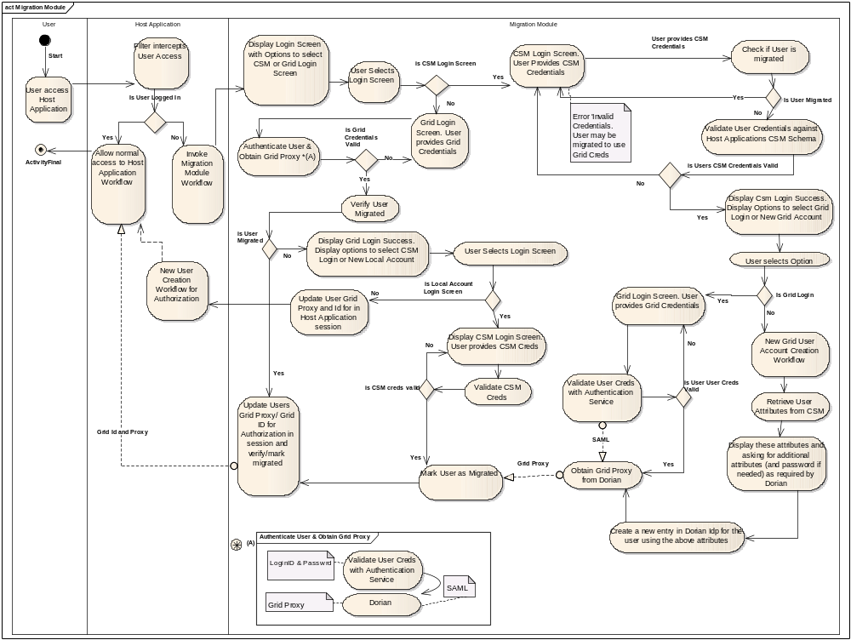
Figure 1: CGMM Activity Diagram

The migration module enables following workflow scenarios described in above activity overview:

- Migrating an existing user who has logged in with his local CSM based credentials

- User with existing grid account
  - CGMM asks the users to log in with their grid credentials.
  - Upon successful Grid authentication it retrieves the user’s proxy and the grid id.
  - CGMM replaces the user’s local CSM Id with the Grid Id and caches the proxy to be retrieved later by the application via the filter
- Users without existing grid account
  - If the user doesn’t have a grid credential, then CGMM retrieves user’s information from CSM for Dorian.
  - CGMM prompts the user to provide any missing information and proceed to create a new user account in Dorian’s IdP.
  - Upon successful creation of user, CMM retrieves the user’s proxy and the grid id.
  - CGMM replaces the user’s local Id with the Grid Id and caches the grid proxy to be retrieved later by the Host application via the filter

In either of the above two cases the control is transferred back to the login module of the Host application. The Host application can retrieve user’s Grid Id and Proxy from the session (which is set by the Filter) indicating a successful authentication and log the user into the application.

- Migrating an existing user who has logged in with his Grid credentials

- CGMM asks the users to log in with their local CSM credentials.
- Upon successful local authentication CGMM retrieves the user’s grid proxy and the grid id from Dorian.
- CGMM replaces the user’s local Id with the Grid Id and caches the proxy to be retrieved later by the Host application.

The control is transferred back to the login module of the Host application. The Host application can retrieve user’s Grid Id and Proxy from the session indicating a successful authentication and log the user into the application.

- Creating a new user in the application who has logged in with his Grid credentials

Upon successful login, the control is transferred back to the new user creation module of the Host application. The Host application can retrieve user’s Grid Id and Proxy from the session and follow its own new user creation workflow.

- Subsequent Login in of the migrated users

Upon successful login, the control is transferred back to the login module of the host application. The Host application can retrieve user’s Grid Id and Proxy from the session indicating a successful authentication and log the user into the application

Deployment Model
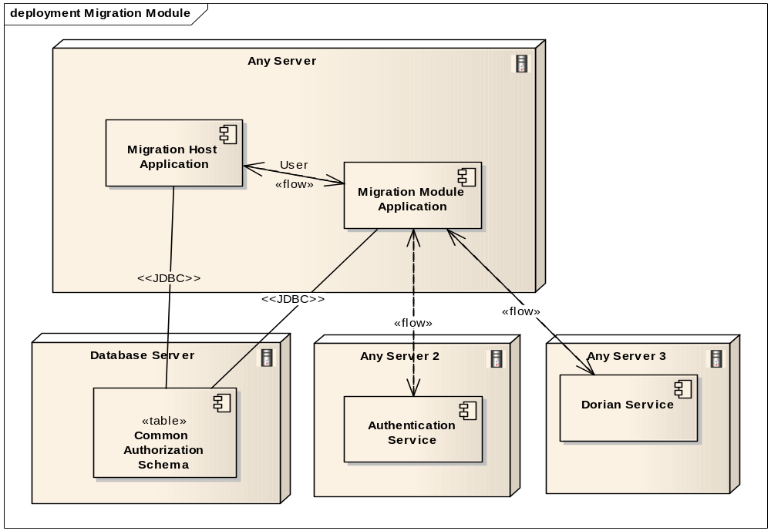

Database Changes
The CSM Authorization Schema is modified to track CSM Users that are migrated with Grid Id.
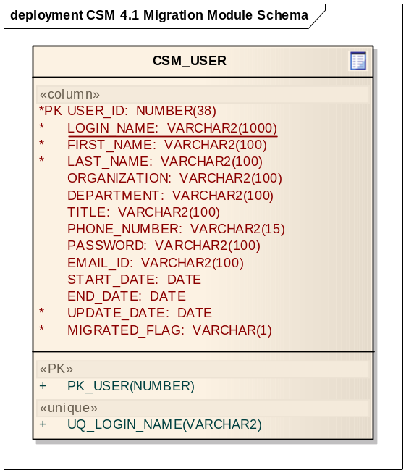

Integration of Migration Module with Host Application

As part of the solution, based on the requirement of seamless integration, the Migration Module and Host Application pass control to and fro seamlessly without User intervention. This integration allows the Migration Module to become part of the Host Application and takeover its Authentication workflow. The Migration Module is intended to implement the Authentication workflow indefinitely for the life of the Host Application until the Host application is refactored to handle GAARDS based authentication.

To enable passing of control between Host Application and CGMM, the Host web Application is configured to enable a Servlet Filter configured in the web.xml. The filter implementation class CGMMMigrationFilter is provided by CGMM. The CGMMMigration Filter implements javax.servlet.Filter interface. The CGMMMigrationFilter checks all User requests and based on the criteria mentioned in section 3.3.1 passes control to CGMM.

Following are the two interactions between the CGMM and the Host application. The interaction is initiated by the Host Application.

Pass of control from Host Application to CGMM

- Scenario 1: User is Not Logged in
  - The User accesses any page on the Host web application.
  - The Servlet request is filtered by CGMMMigrationFilter.
  - CGMMMigrationFilter determines it’s a new Session or User is not logged in.
  - CGMMMigrationFilter obtains the ServletContext of CGMM.
  - CGMMMigrationFilter obtains the RequestDispatcher Object from ServletContext and invokes the RequestDispatcher.include() method to pass control to CGMM Home Page
  - Without User intervention the control is passed to CGMM.
- Scenario 2: User is Logged in
  - The User accesses any page on the Host Web application
  - The Servlet request is filtered into CGMMMigrationFilter.
  - CGMMMigrationFilter checks Session attributes and determines User is logged.
  - The CGMMMigrationFilter gives up control to the next Filter in chain.
  - The User is allowed access to the designated Host Web Application Page.

Passing of control from CGMM to Host Application
The passing of control between CGMM to Host Application is done in same fashion, as described in section 3.3.1, i.e using ServletContext and RequestDispatcher.

Based on the scenarios mentioned in CGMM Workflow Section 3.2.2, the following are the resulting outcome scenarios for which control is passed from CGMM to Host Application.

- Scenario 1: User has local account and is authenticated
  - CGMM has Grid Proxy and Grid Id of the authenticated Grid User.
  - CGMM obtains the ServletContext of the Host Web Application.
  - CGMM puts the Grid Proxy and Grid Id as attributes of the Request object.
  - CGMM obtains the RequestDispatcher Object from ServletContext and invokes the RequestDispatcher.forward() method to pass control to Host Web Applications User Home Page
  - The Host Web Application inspects the request and obtains Grid Proxy and Grid Id.
  - The Grid Proxy and Grid Id are stored in Session.
  - The Host Web Application uses the Grid Id for Authorization.
  - Without User intervention the control is passed to Host Web Application.
- Scenario 2: User is does not have a local account and is authenticated by Grid.
  - CGMM has Grid Proxy and Grid Id of the authenticated Grid User.
  - CGMM obtains the ServletContext of the Host Web Application.
  - CGMM puts the Grid Proxy and Grid Id as attributes of the Request object.
  - CGMM obtains the RequestDispatcher Object from ServletContext and invokes the RequestDispatcher.forward() method to pass control to Host Web Applications New User creation page.
  - The Host Web Application inspects the request and obtains Grid Proxy and Grid Id.
  - The Grid Proxy and Grid Id are stored in Session.
  - The User is presented the designated page for New User Creation workflow of the Host Application (or to the Home Page if New User Creation workflow is not available).

Interaction of Migration Module with Authentication Service

The Host application configures the CGMM with a list of IdPs and their URL’s against which the User Grid Credentials can be validated. The configuration details are available in section 4.1. CGMM presents this list to the User on the Grid Login Page.

Based on the workflow scenarios mentioned in CGMM Workflow section 3.2.2, the User has to be authenticated by the Authentication Service chosen by the User on the CGMM Grid Login Screen.

Following is the interaction of CGMM with Authentication Service.

- User is on the CGMM Grid Login Page.
- User provides the Grid Login Id and Password.
- User selects an Authentication Service from the presented list of IdPs.
- User clicks the Login button.
- CGMM invokes the Authentication Service selected by the User and passes credentials.
- If the User credentials are valid, the Authentication Service returns a SAML Assertion.
- If the User credentials are invalid, the Authentication Service throws an Exception.

Interaction of Migration Module with Dorian Service

The Host application configures the CGMM with the URL of the Dorian Service. The configuration details are available in section 4.1. The CGMM invokes the Dorian service to obtain Grid Proxy and Grid Id. The Grid Proxy is necessary to pass control to the Host Application.
The CGMM uses Dorian to host all the users migrated from individual local host application instances which are not associated to any other IdPs.

Based on the scenarios mentioned in CGMM Workflow Section 3.2.2, the following are the resulting scenarios for which control is passed between CGMM and Dorian

- Scenario 1: CGMM gets SAML Assertion from Authentication Service indicating User is authenticated.
  - CGMM authenticates User with grid credentials against the Authentication Service
  - CGMM gets the SAML from Authentication Service
  - CGMM passes the SAML assertion and Authentication Service URL to Dorian
  - CGMM obtains Users Grid Proxy and retrieves Grid Id.
  - CGMM passes control to appropriate Host Web Application Page depending on whether User has local account or not.
- Scenario 2: User doesn’t have Grid Account
  - CGMM retrieves Users information from CSM schema.
  - CGMM asks User to provide missing information (and new password) to create an account in Dorian IdP.
  - CGMM creates a new User entry in Dorian IdP for the user using above information.
  - CGMM obtains Grid Proxy and Grid Id from Dorian.
  - CGMM passes control to appropriate Host Web Application Page.

Unit Testing

JUnit Test Cases
This solution requires integration with a Host Web Application and is also dependent on Grid Components that need to be deployed and be up and running. Hence automated HTTPUnits/JUnit will not be available.

Integration tests will be performed and provided for various flows and exceptions paths.

Test Case Scenarios
The test case scenarios will be developed in conjunction with the QA Team. Based on the initial design the overall test scenarios are as mentioned below. Note that based on data each of these scenarios can have multiple test cases

  - Testing Users CSM Authentication
  - Testing Users Grid Authentication
  - Testing new Grid User Creation
  - Testing Filter intercepting on Migration Host Application
  - Testing passing of authenticated Users Grid Identity and Grid Proxy to Migration Host Application

Configuration/Deployment Considerations

Property/Configuration Files
- Migration Module Properties file: CGMM.properties
  - List of supported IdPs ( Authentication Service and Dorian IdP URLs)
  - Dorian URL
  - CSM Application Context name of Host application – for CSM Authentication
  - Host Application Context Name
  - Host Application Home Page URI
  - Host Application New User Creation Page URI
- Login-config – Entry for LoginModule(s) for CSM Authentication.
- JNDI Data source – Pointing to the Host Applications CSM Schema
- Sync-description.xml – SyncGTS configuration file.

Deployment Considerations

- The Migration Module and Host Application will have to install and run Sync GTS to establish the Grid Trust Fabric.
- The Migration Module will be deployed along with the Host Application in its container. The Migration Module will use the Host Applications Host Credentials to access the Authentication and Dorian services.

